

|  |  |  |  |  |  |  |  |  |
| --- | --- | --- | --- | --- | --- | --- | --- | --- |
|  | | | | | | | | |
|  | | Database And Management System | | | | |  | |
|  |  | | | | | | |  |
|  | | | |  |  | | | |
|  | | | | Project Report |  | | | |
|  | | | | 06 December 2022—Mis Eman Shahid—Sir Ahmed Budhi |  | | | |
|  | | |  | | |  | | |

**Group Members**

* Ahad Shaikh (20K-0319)
* Basil Ali Khan (20K-0477)
* Ali Jodat (20K-0155)

**ABSTRACT**

tock Market System is a system which enables individuals and organizations to trade shares

and company stocks in the stock markets. It enables everyone to invest their money and

manage and maintain their individual portfolios. It is a user-friendly system which makes it

easy to trade, find and invest in new companies which may interest them. We can also see the

historical prices through the system including the companies open, high, close etc. on the

Nifty 50 stock market which I have used as a base for this project. The system also allows us

to trade and sell different stocks.

tock Market System is a system which enables individuals and organizations to trade shares

and company stocks in the stock markets. It enables everyone to invest their money and

manage and maintain their individual portfolios. It is a user-friendly system which makes it

easy to trade, find and invest in new companies which may interest them. We can also see the

historical prices through the system including the companies open, high, close etc. on the

Nifty 50 stock market which I have used as a base for this project. The system also allows us

to trade and sell different stocks.

Hospital Management System is a system which enables Admin to register and remove Doctors and check pharmacy medicines stocks. Doctors can only login can check their appointment timings and update them according to availability and update their data if they want. Individual Patients can register and login and check their hospital updated record. It enables patients to not only login and register themselves but also can booked appointments online with the availability of Doctor at particular time and date, they can also check if the hospital’s pharmacy has medicine available and can buy them which results in generation of token number that will be showed to pharmacist. It is a user-friendly system which makes it easy to login, register, update records, check and book appointments. Admin can also add stocks when he sees something out of stock.

## Table of Contents

Contents

Database And Management System 1

Project Report 1

Chapter 1 4

INTRODUCTION 4

Chapter 2 6

REQUIREMENT SPECIFICATION 6

Chapter 3 7

DETAILED DESIGN 7

Chapter 4 12

IMPLEMENTATION 12

Chapter 5 17

TESTING 17

Chapter 6 18

SNAPSHOTS 18

Chapter 7 26

CONCLUSION 26

Chapter 8 27

FUTURE ENHACEMENTS 27

REFERENCES 28

## Chapter 1

## INTRODUCTION

#### OVERVIEW

Hospital and Management System is designed to help Patients and Doctors to register, login, update their records. It enables patients to book appointment and check medicine availability at pharmacy and book them with token number. It also enables patients to view specialist according to their symptoms and booked appointments. It also allows them to view their total profiles, appointment timing and stock availability.

#### PROBLEM STATEMENT

1. The main aim of “Stock Market System” is to make and easy interface for bankers,
2. investors and businesses to make systematic decisions on the stock market and help
3. them invest in the stocks of their choice

The main aim of Hospital Management System is to make an easy interface for Admin, Patients and Doctors to login, register, and update and help them buy medicines and booked appointment of their choice.

#### 1.3 DATABASE AND MANAGEMENT SYSTEM

A database management system (DBMS) is system software for creating and

managing databases. The DBMS provides users and programmers with a systematic

way to create, retrieve, update and manage data. The DBMS essentially serves as an

interface between the database and end users application programs, ensuring that data

is consistently organized and remains easily accessible.

The DBMS manages three important things: the data, the database engine that allows

data to be accessed, locked and modified, and the database schema, which defines the

A database management system (DBMS) is system software for creating and managing databases. The DBMS provides users and programmers with a systematic way to create, retrieve, update and manage data. The DBMS essentially serves as an interface between the database and end users application programs, ensuring that data is consistently organized and remains easily accessible.

The DBMS manages three important things: the data, the database engine that allows data to be accessed, locked and modified, and the database schema, which defines the database’s logical structure. These three foundational elements help to provide concurrency, security, data integrity and uniform administration procedures. Typical database administration tasks supported by the DBMS include change management, performance monitoring/tuning and backup and recovery. Many database management systems are also responsible for automated rollbacks, restarts and recovery as well as the logging and auditing of activity.

#### 1.4 SUPABASE

SupaBase is open source. We choose open source tools which are scalable and make them simple to use.

SupaBase is not a 1-to-1 mapping of Firebase. While we are building many of the features that Firebase offers, we are not going about it the same way: our technological choices are quite different; everything we use is open source; and wherever possible, we use and support existing tools rather than developing from scratch.

Most notably, we use PostgreSQL rather than a NoSQL store. This choice was deliberate. We believe that no other database offers the functionality required to compete with Firebase, while maintaining the scalability required to go beyond it.

#### 1.5 FLUTTER

Flutter – a simple and high performance framework based on Dart language, provides high performance by rendering the UI directly in the operating system’s canvas rather than through native framework.

Flutter also offers many ready to use widgets (UI) to create a modern application. These widgets are optimized for mobile environment and designing the application using widgets is as simple as designing HTML.

To be specific, Flutter application is itself a widget. Flutter widgets also supports animations and gestures. The application logic is based on reactive programming. Widget may optionally have a state. By changing the state of the widget, Flutter will automatically (reactive programming) compare the widget’s state (old and new) and render the widget with only the necessary changes instead of re-rendering the whole widget.

#### 1.6 SUPABASE-FLUTTER

SupaBase-Flutter focuses on improving the developer experience and making it easier to use.

You can use the SupaBase-Flutter library to:

* interact with your Postgres database
* listen to database changes
* invoke Deno Edge Functions
* build login and user management functionality
* manage large files

If you have related data and want to make it real-time, SupaBase is a good alternative for the following reasons:

It uses a PostgreSQL database with real-time capabilities - A very scalable relational database. You can manage your database from the SupaBase interface.

Create tables and relationships etc. (Firebase does not offer this).

* Write SQL Queries
* Enable & disable extensions.
* Real-time engine on top of Postgres.
* Post REST API - Take your database (Tables and columns) and automatically generate a REST API from that with Filtering, Sorting etc. You can access your data through that API in either your Flutter App, React App, etc.
* Authentication with multiple methods/services - Create and manage users from SupaBase:
  + Email/Password
  + Magic Link
  + Google
  + GitHub
  + Facebook
  + File storage.
  + Server less functions

## Chapter 2

## REQUIREMENT SPECIFICATION

A computerized way of handling information about property and users details is efficient,

organized and time saving, compared to a manual way of doing so. This is done through a

database driven web application whose requirements are mentioned in this section.

A computerized way of handling information about doctor, patient, ticket and appointment details is efficient, organized and time saving, compared to a manual way of doing so. This is done through database driven mobile application whose requirements are mentioned in this section.

##### 2.1 OVERALL DESCRIPTION

A reliable and scalable database driven mobile application with security features that is easy to use and maintain is the requisite.

#### 2.2 SPECIFIC REQUIREMENTS

The specific requirements of the Stock Market System are stated as follows:

##### 2.2.1 SOFTWARE REQUIREMENTS

* IDE – Visual Studio Code
* Emulator – Android Studio
* Android Version – 11.0
* Dart – 2.18.4

##### 2.2.2 HARDWARE REQUIREMENTS

* Octa-core (4x2.0 GHz Kryo 260 Gold & 4x1.8 GHz Kryo 260 Silver)
* RAM – 4 GB or more
* Screen Resolution – 720 x 1500
* Hard disk – 3 GB or more
* Touch Screen

##### 2.2.3 TECHNOLOGY

* Dart is a client-optimized language for developing fast apps on any platform. Its goal is to offer the most productive programming language for multi-platform development, paired with a flexible execution runtime platform for app frameworks.
* SupaBase(Postgres) is the language used to manipulate relational databases. It is tied closely with the relational model. It is issued for the purpose of data definition and data manipulation.

## Chapter 3

## DETAILED DESIGN

#### 3.1 SYSTEM DESIGN

Each SupaBase project consists of several tools:

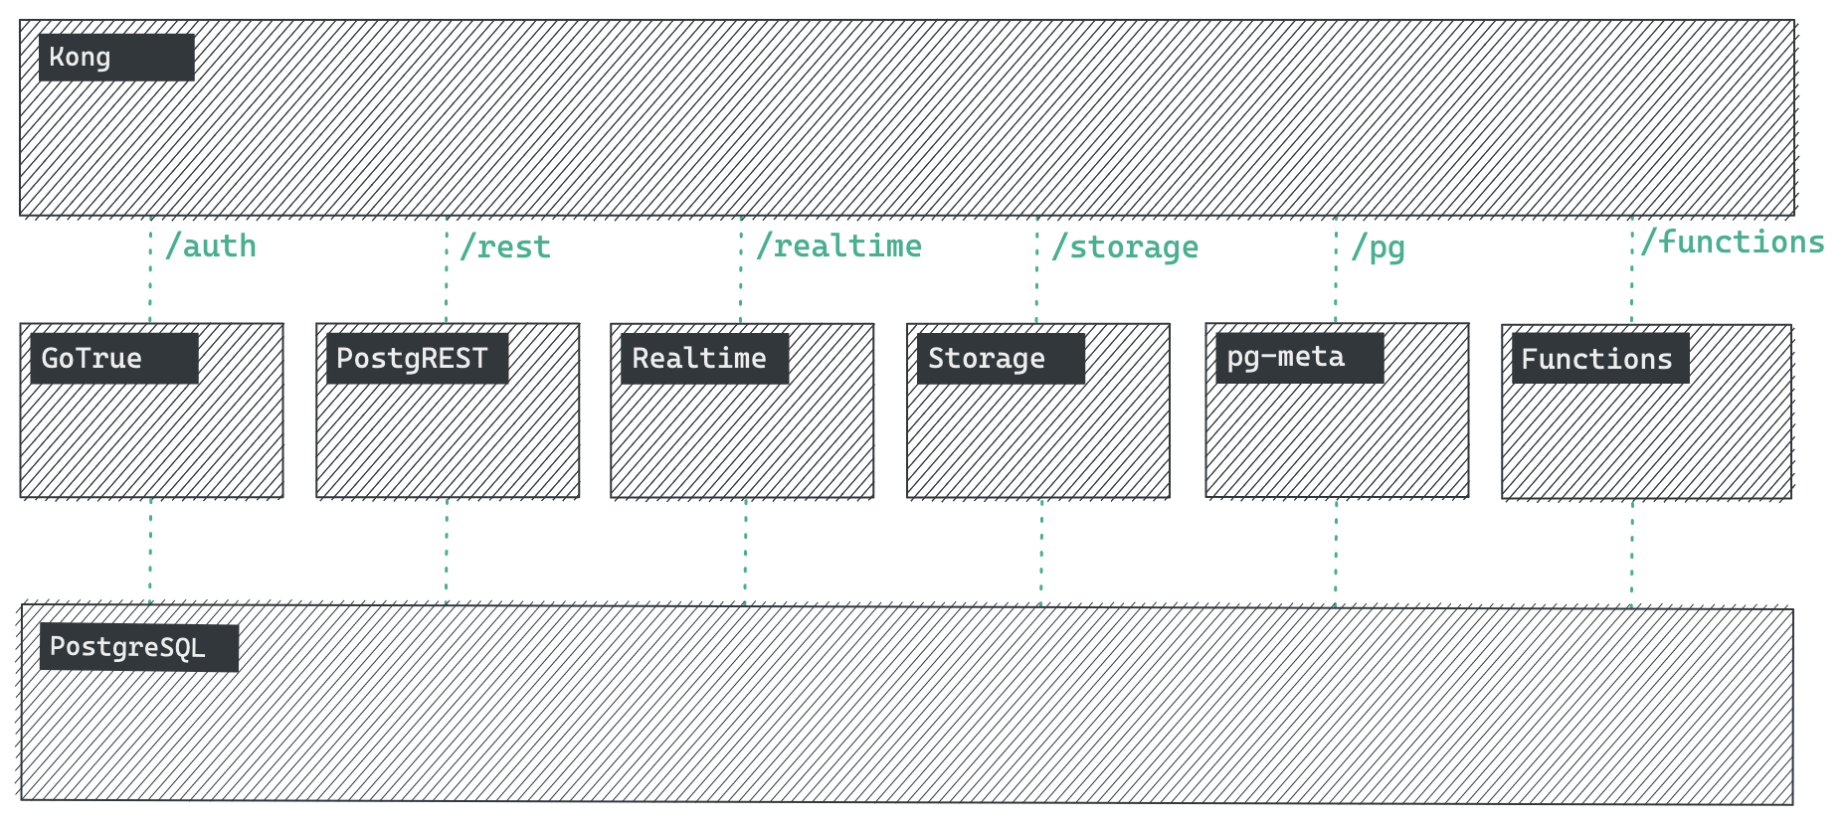

**PostgreSQL (Database):**

PostgreSQL is the core of SupaBase. We do not abstract the PostgreSQL database — you can access it and use it with full privileges. We simply provide tools which makes PostgreSQL as easy to use as Firebase.

**Studio (Dashboard):**

An open source Dashboard for managing your database and services.

**GoTrue (Auth):**

A JWT-based API for managing users and issuing access tokens. This integrates with PostgreSQL's Row Level Security and the API servers.

**PostgREST (API):**

A standalone web server that turns your PostgreSQL database directly into a RESTful API. We use this with our pg_graphql extension to provide a GraphQL API.

**Realtime (API & multiplayer):**

A scalable websocket engine for managing user Presence, broadcasting messages, and streaming database changes.

**Storage API (large file storage):**

An S3-compatible object storage service that stores metadata in Postgres.

**Deno (Edge Functions):**

A modern runtime for JavaScript and TypeScript.

**postgres-meta (Database management):**

A RESTful API for managing your Postgres. Fetch tables, add roles, and run queries.

**PgBouncer:**

A lightweight connection pooler for PostgreSQL. This is useful for connecting to Postgres when using Server less functions.

**Kong (API Gateway):**

A cloud-native API gateway, built on top of Nginx.

#### 3.2 ENTITY RELATIONSHIP DIAGRAM

An entity–relationship model is usually the result of systematic analysis to define and describe what is important to processes in an area of a business.

An E-R model does not define the business processes; it only presents a business data schema in graphical form. It is usually drawn in a graphical form as boxes (entities) that are connected by lines (relationships) which express the associations and dependencies between entities.

Entities may be characterized not only by relationships, but also by additional properties(attributes), which include identifiers called "primary keys". Diagrams created to represent attributes as well as entities and relationships may be called entity-attribute-relationship diagrams, rather than entity-relationship models.

An ER model is typically implemented as a database. In a simple relational database implementation, each row of a table represents one instance of an entity type, and each field in a table represents an attribute type. In a relational database a relationship between entities is implemented by storing the primary key of one entity as a pointer or "foreign key" in the table of another entity.

There is a tradition for ER/data models to be built at two or three levels of abstraction. Note that the conceptual-logical-physical hierarchy below is used in other kinds of specification, and is different from the three schema approach to software engineering. While useful for organizing data that can be represented by a relational structure, an entity-relationship diagram can't sufficiently represent semi-structured or unstructured data, and an ER Diagram’s unlikely to be helpful on its own in integrating data into a pre-existing information system.

Cardinality notations define the attributes of the relationship between the entities. Cardinalities can denote that an entity is optional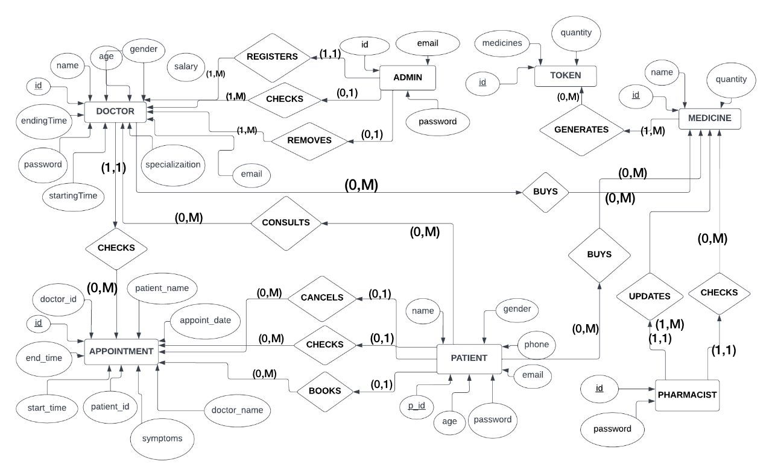

#### 3.3 RELATIONAL SCHEMA

The term "schema" refers to the organization of data as a blueprint of how the database is constructed. The formal definition of a database schema is a set of formulas called integrity constraints imposed on a database. A relational schema shows references among fields in the database. When a primary key is referenced in another table in the database, it is called a foreign key. This is denoted by an arrow with the head pointing at the referenced key attribute. A schema diagram helps organize values in the database. The following diagram shows the schema diagram for the database.

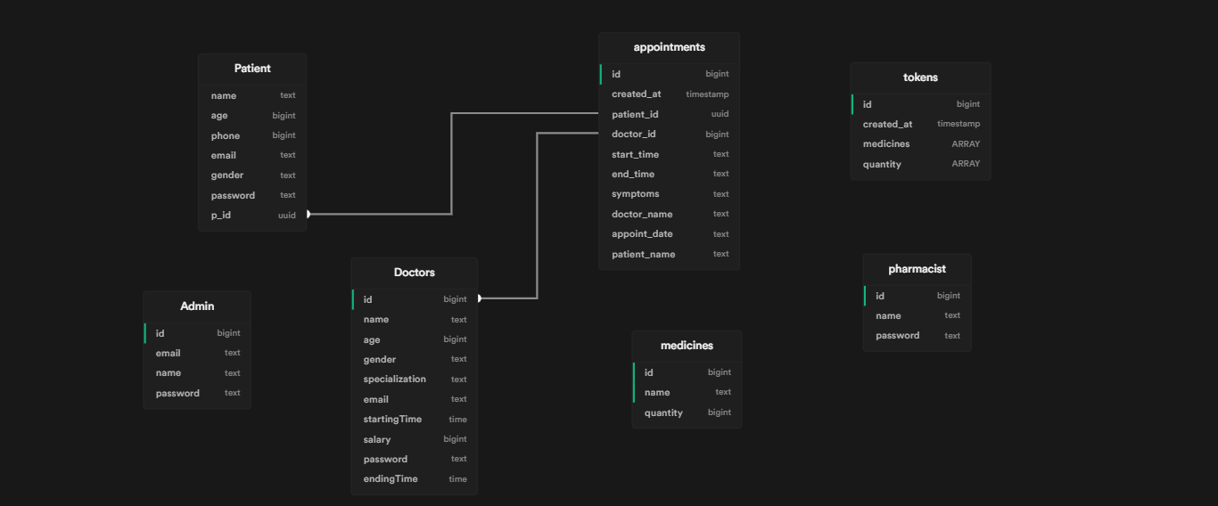

#### 3.4 DESCRIPTION OF TABLES

The database consist of 7 tables.

1. Admin:
   1. Id
   2. Email
   3. Name
   4. Password
2. Pharmacist:
   1. Id
   2. Name
   3. Password
3. Doctor:
   1. Id
   2. Name
   3. Age
   4. Gender
   5. Specialization
   6. Email
   7. Starting time
   8. Ending time
   9. Salary
   10. Password
4. Patient:
   1. Name
   2. Age
   3. Phone
   4. Email
   5. Gender
   6. Password
   7. P_id
5. Appointments:
   1. Id
   2. Created at
   3. Patient_id
   4. Doctor_id
   5. Start_time
   6. End_time
   7. Symptoms
   8. Doctor_name
   9. Appointment_date
   10. Patient_name
6. Medicines:
   1. Id
   2. Name
   3. Quantity
7. Tokens:
   1. Id
   2. Created_at
   3. Medicines
   4. Quantity

## Chapter 4

## IMPLEMENTATION

#### MODULES AND THEIR ROLES

##### DISPLAYING DOCTOR APPOINTMENTS

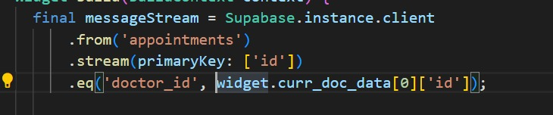

##### REGISTER DOCTOR

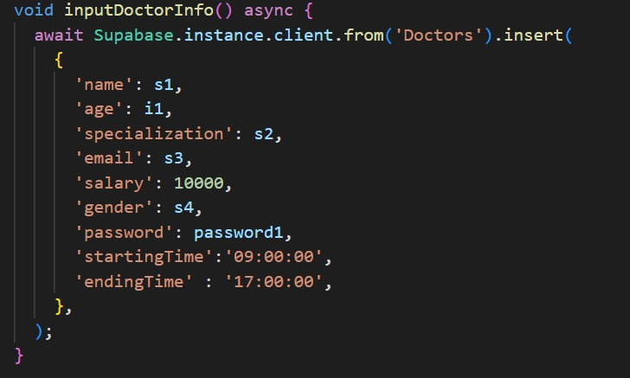

##### REMOVING DOCTOR

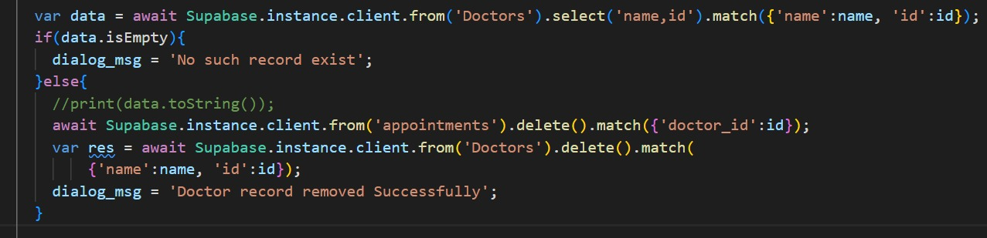

##### SHOWING DOCTOR DETAILS

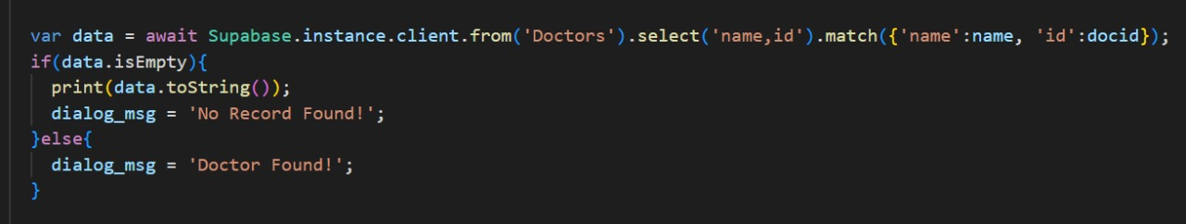

##### BOOKING PATIENT APPOINTMENT

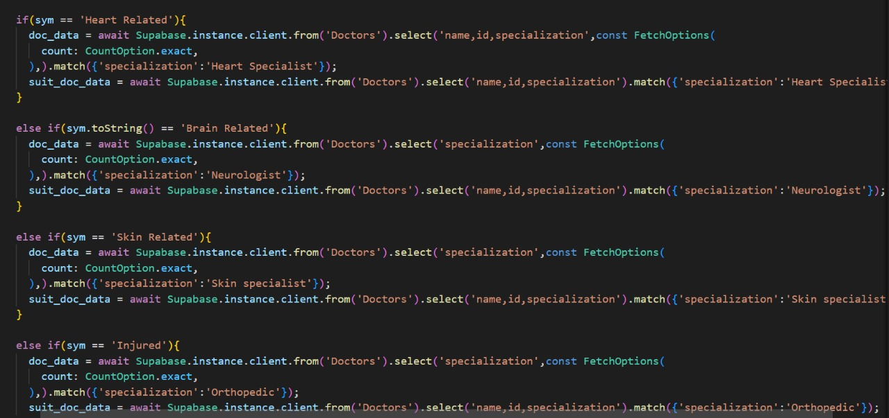

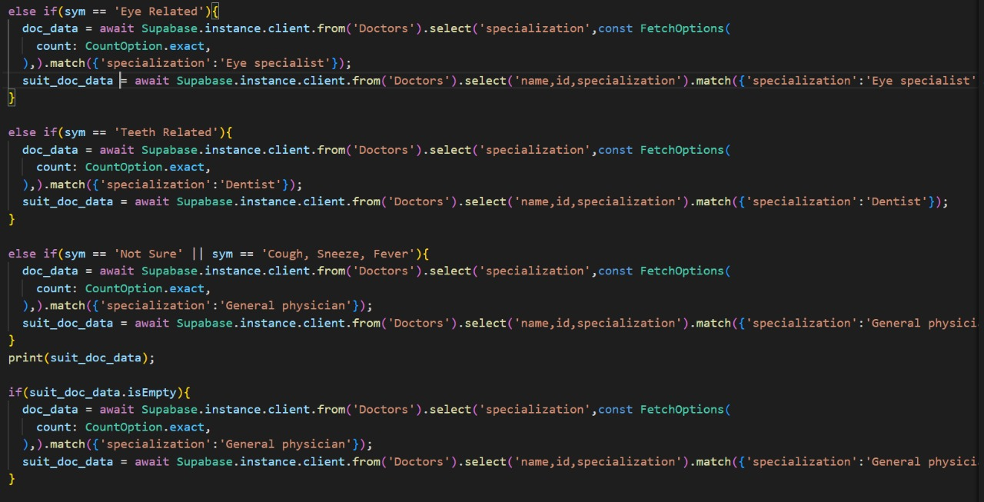

##### 4.1.6 CANCELLING APPOINTMENT

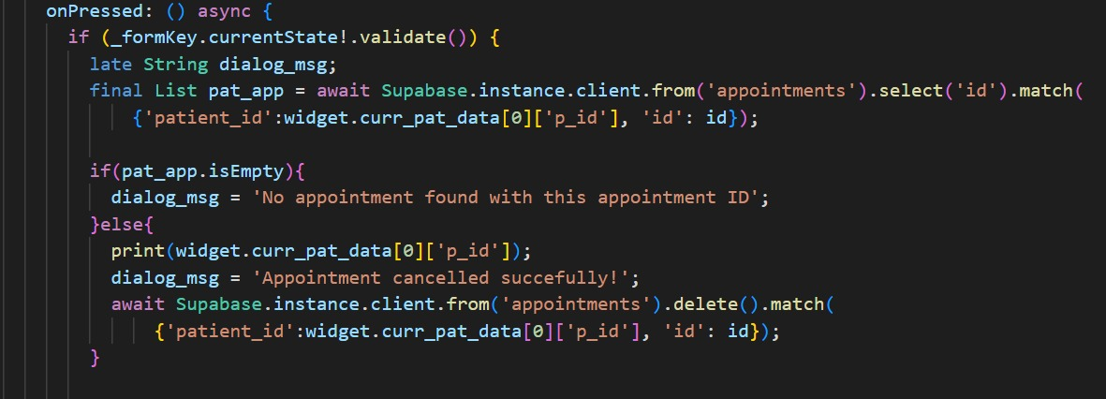

##### DISPLAYING PATIENT APPOINMENTS

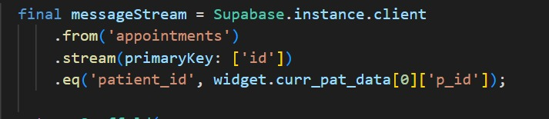

##### UPDATING DOCTOR DETAILS

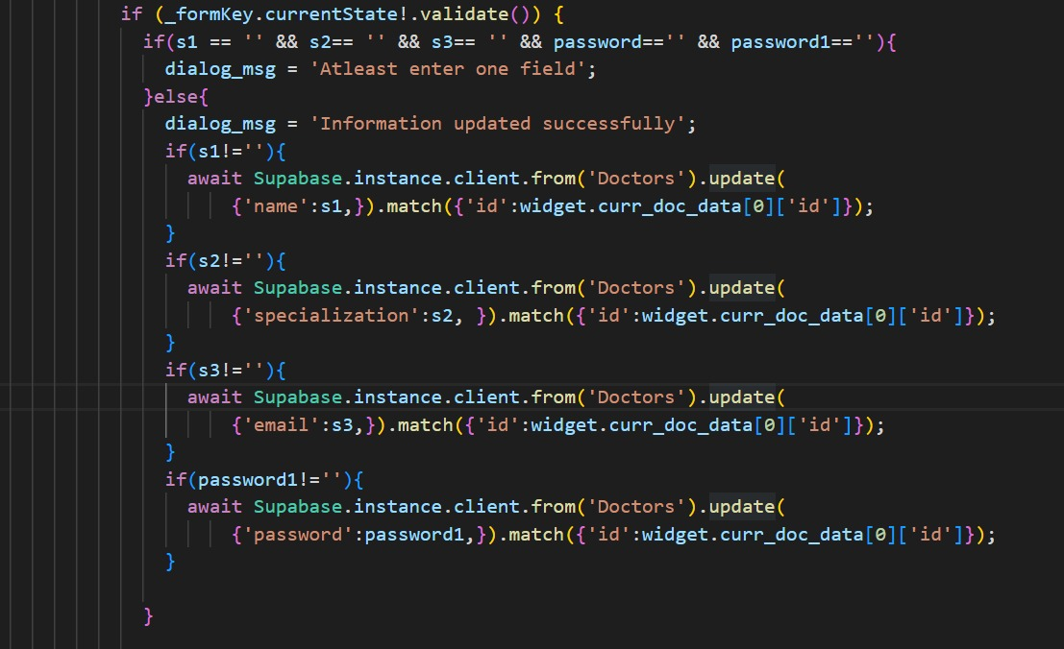

##### UPDATE MEDICINES IN STOCK

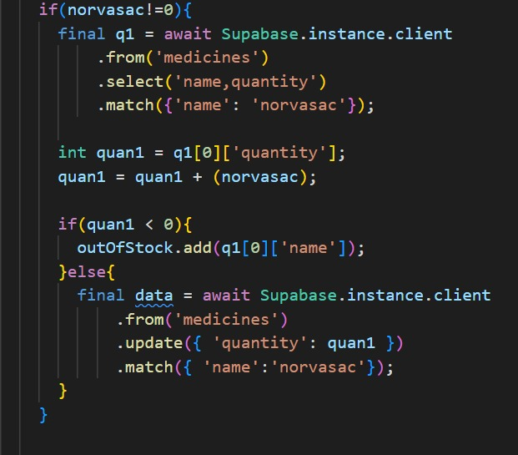

##### SHOW MEDICINE IN STOCK



##### 4.2 RESULT

* Authenticate Admin, Patient and Pharmacist
* Admin login and Pharmacist login
* Admin
  + Registers Doctor
  + Removes Doctor
  + Check Doctor details
* Doctor
  + Update his/her details
  + Check his Appointments
* Patient
  + Registers himself
  + Login
  + Book Appointment
  + Cancel Appointment
  + BMI calculator
  + Diet Suggestion
* Random User (Without Login/Registration)
  + Buy medicines
* Pharmacist
  + Login
  + Update stock

## Chapter 5

## TESTING

#### 5.1 SOFTWARE TESTING

Testing is the process used to help identify correctness, completeness, security and quality of developed software. This includes executing a program with the intent of finding errors. It is important to distinguish between faults and failures. Software testing can provide objective, independent information about the quality of software and risk of its failure to users or sponsors. It can be conducted as soon as executable software (even if partially complete) exists. Most testing occurs after system requirements have been defined and then implemented in testable programs.

#### 5.2 MODULE TESTING AND INTEGRATION

Module testing is a process of testing the individual subprograms, subroutines, classes, or procedures in a program. Instead of testing whole software program at once, module testing recommend testing the smaller building blocks of the program. It is largely white box oriented. The objective of doing Module testing is not to demonstrate proper functioning of the module but to demonstrate the presence of an error in the module. Module testing allows implementing of parallelism into the testing process by giving the opportunity to test multiple modules simultaneously. The final integrated system too has been tested for various test cases such as duplicate entries and type mismatch

## Chapter 6

## SNAPSHOTS

This chapter consists of working screenshots of the project.

#### Front Page:

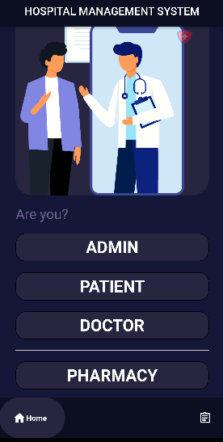

#### Admin:

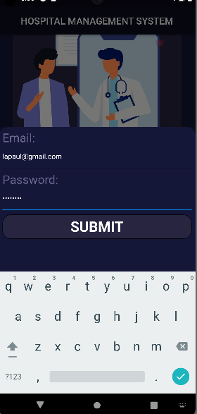

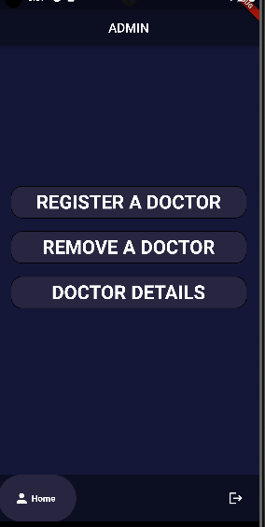

#### Patient

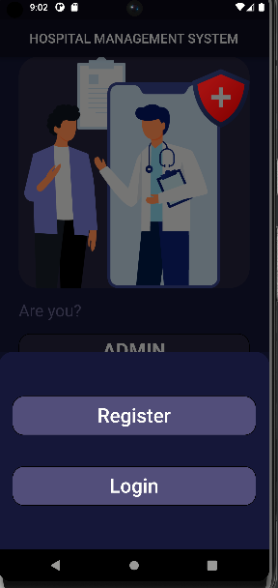

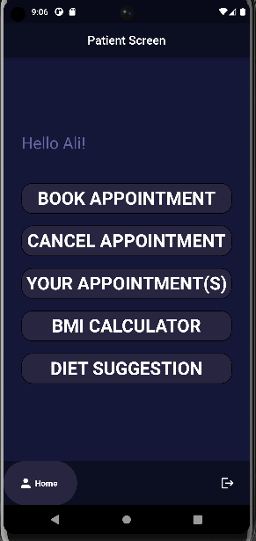

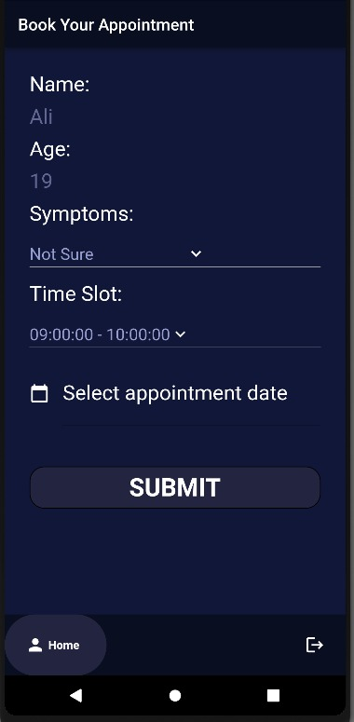

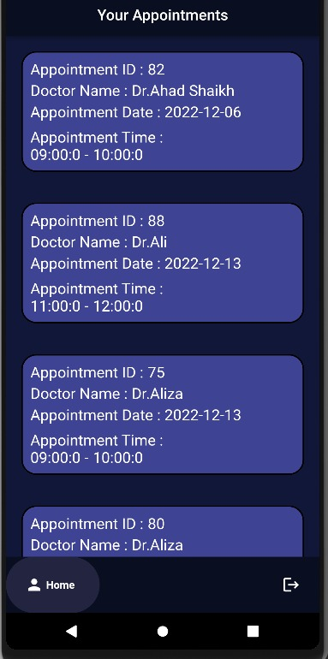

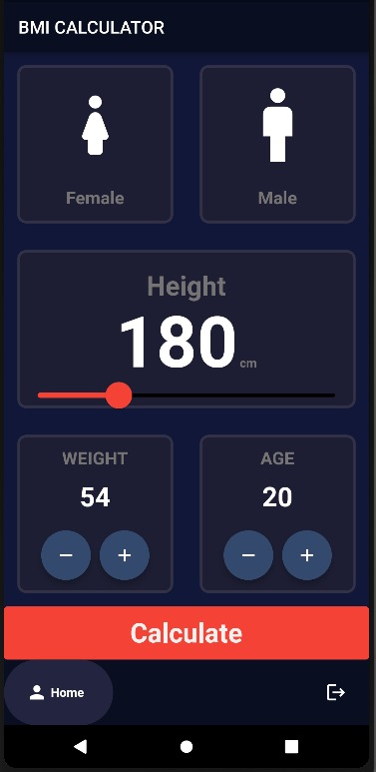

#### Doctor:

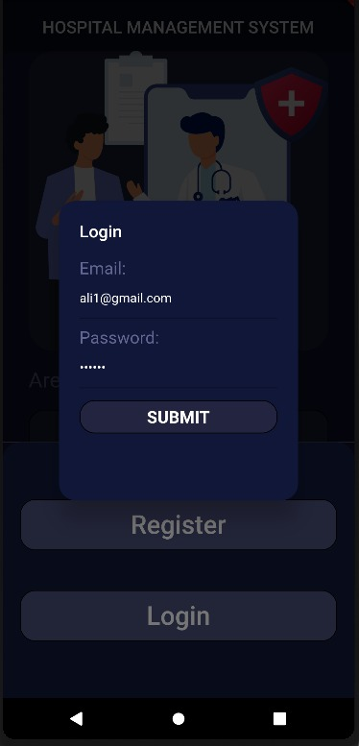

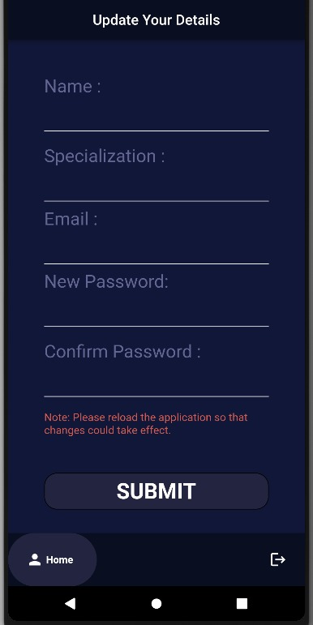

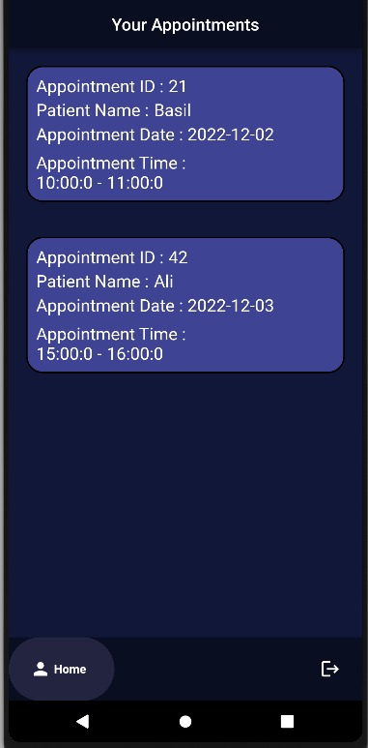

#### Pharmacist:

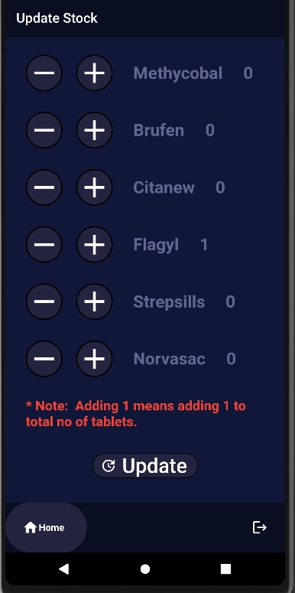

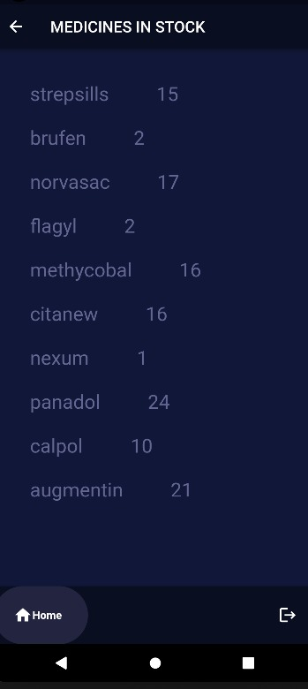

#### Random User:

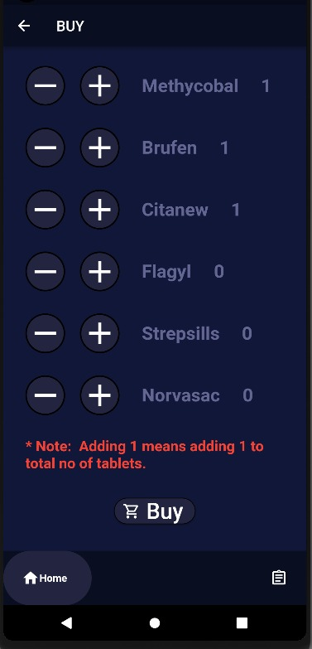

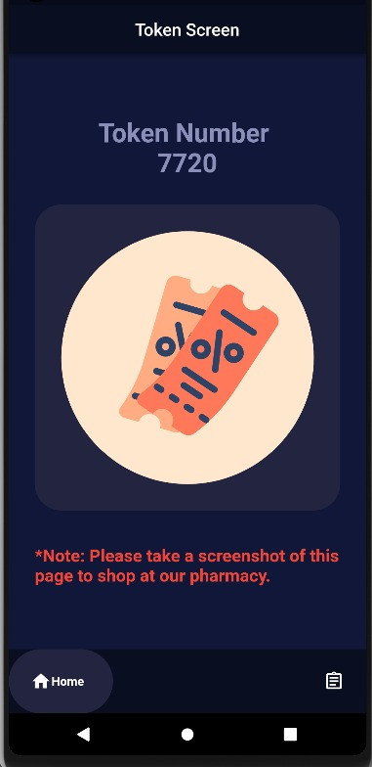

#### About Us:

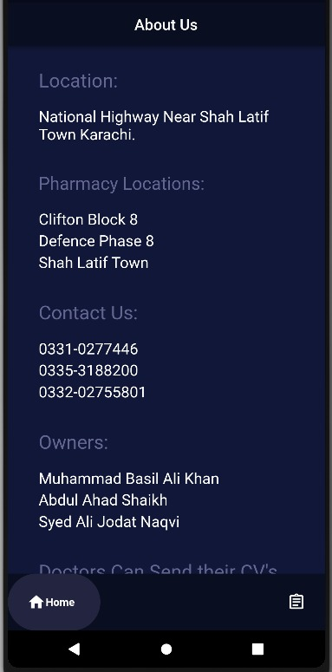

## Chapter 7

## CONCLUSION

The Hospital Management System provides easier maintenance of doctor registration and stock maintenance. It allows simplified operation and is a time saving platform with the ability to view and update data and easily book and view appointments and buy medicines. The application has been completed successfully and tested with suitable test cases. It is user friendly and contains suitable options for admin, doctors and patients. This is developed using Flutter (DART) and SupaBase. The goals achieved by this project are:

Centralized database

¬Easier buying, selling of various stocks.

¬User friendly environment.

¬

Efficient management of stocks.

¬

Ability to view historical data and analyse them for better growth.

¬View profits and loss statements, current investments in various companies

* Centralized database
* Easier buying medicines and booked appointments
* User friendly environment.
* Efficient management of stocks.
* Ability to view data and also update it

## Chapter 8

## FUTURE ENHACEMENTS

Future upgrades to this project will implement:

* Give notification of appointments to user when is appointment date time is near.
* Buy medicine online checkout payment feature can be added
* Online consultation through video chat.
* Adding more medicine stock.

## REFERENCES

<https://supabase.com/docs/reference/dart/upgrade-guide>

<https://dart.dev/>

<https://mega.nz/folder/3WhSkBjJ#YSDBnDegckd9-xSQ04W0qA/folder/HXxyyDiQ>

<https://docs.flutter.dev/>

“Stock Market System” is designed to help invest and trade in stocks, shares and

1. currencies on the international stock market system. It enables us to view all the
2. historical data on the companies present in the stock market and make smart
3. investments decisions.
4. It also enables us to view and trade on the current investments made by customer and
5. thus help them decide whether to trade and sell those stocks or to buy any more stocks.
6. It also allows them to view their total profits and loss made on the stock markets.